
a
Company
Logotype

Cone Beam Computed Tomography- Report



Porur Dental X-rays & CBCT

Patient Name : Mr. Siddharth | Date of Report : 30.08.2025
Age/ Gender : 34 years/ Male | Region of Interest : CBCT Sectional Mandible
Referring doctor: Dr. Selva Ganesh | Indication : Implant assessment
Clinical Notes: Nil
PATIENT INFORMATION

CBCT- Sectional Mandible provided
CBCT – IMAGE DETAILS

RADIOGRAPHIC INTERPRETATION

- Completely mission crown and root portion of 36, 37.
- In relation to the edentulous region of 36, there is an oval hypodense region within the alveolar bone measuring 4.72 x 5.36 x 5.83 mm suggesting residual infection.
- The portion of inferior alveolar nerve canal just below to the edentulous 36 region is present with sclerotic rimming along the lower border (Kindly refer attached cross sectional image- red arrow).
- Bone density in relation to 36 region: 637.30 HU
 | 36 region
Sub-Crestal (in mm) | 10.39
Width along the middle third of alveolar ridge  (in mm) | 10.39
Distance between alveolar ridge and the inferior alveolar nerve canal (in mm) | 9.24
Distance between alveolar ridge and the inferior border of mandible (in mm) | 18.99
IMPLANT ASSESSMENT

RADIOGRAPHIC IMPRESSION

- Partially edentulous region: 36, 37

Kindly correlate with history and clinical findings


IMAGES FOR REFERENCE

RECONSTRUCTED PANORAMIC VIEW
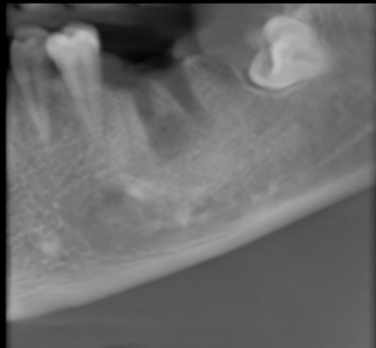

3-DIMENSIONAL VIEW
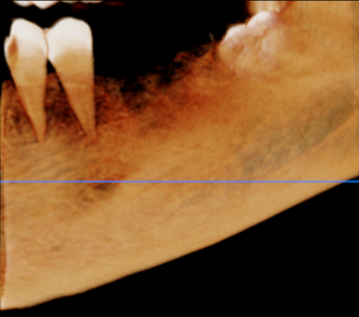

CROSS SECTIONAL VIEW

36 region | 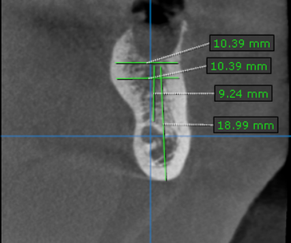  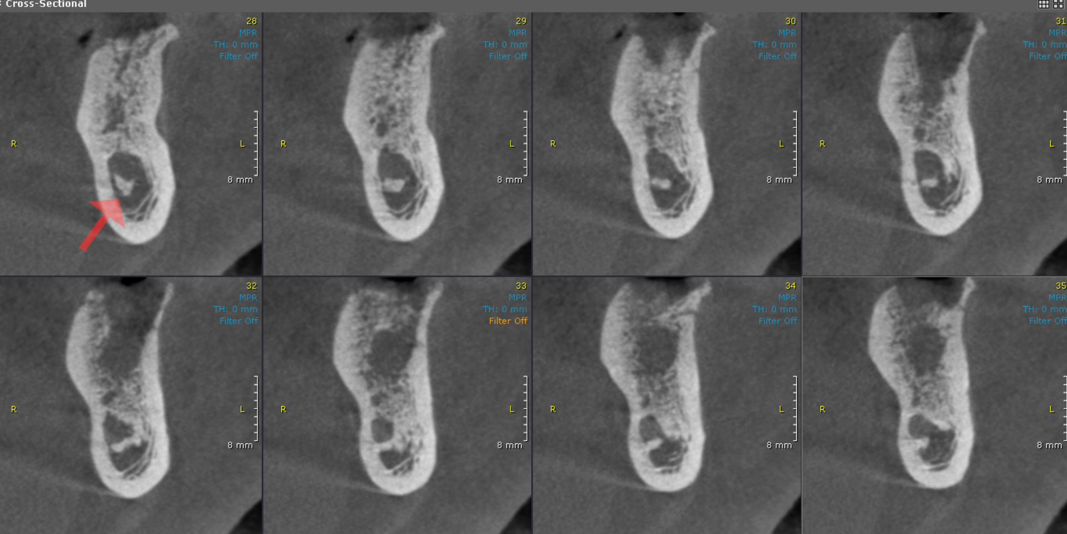

**** End of report ****

